**DAILY ONLINE ACTIVITIES SUMMARY**

|  |  |  |  |  |  |  |  |
| --- | --- | --- | --- | --- | --- | --- | --- |
| **Date:** | **13/06/2020** | | | | **Name:** | **Sinchana K N** | |
| **Sem & Sec** | **IV sem & B section** | | | | **USN:** | **4AL18CS083** | |
| **Online Test Summary** | | | | | | | |
| **Subject** | | **Data Communication** | | | | | |
| **Max. Marks** | | **30** | | **Score** | | **27** | |
| **Certification Course Summary** | | | | | | | |
| **Course** | **Cloud foundation** | | | | | | |
| **Certificate Provider** | | | **Greatlearning academy** | **Duration** | | | **5.0 hours** |
| **Coding Challenges** | | | | | | | |
| **Problem Statement1:** Write a C Program to calculate Electricity Bill.  **Problem Statement2:** How to find the first non-repeated character of a given String in java. | | | | | | | |
| **Status: Executed** | | | | | | | |
| **Uploaded the report in Github** | | | | **YES** | | | |
| **If yes Repository name** | | | | **https://github.com/acchu1234sinchana/Lockdown_coding1** | | | |
| **Uploaded the report in slack** | | | | **YES** | | | |

Online Test Summary: 18CS46 test was scheduled from 2:00pm t0 2:30pm .The portion for the IA was 1st and 2nd module there were 30 questions and the time assigned was 30 minutes the questions were mcq type.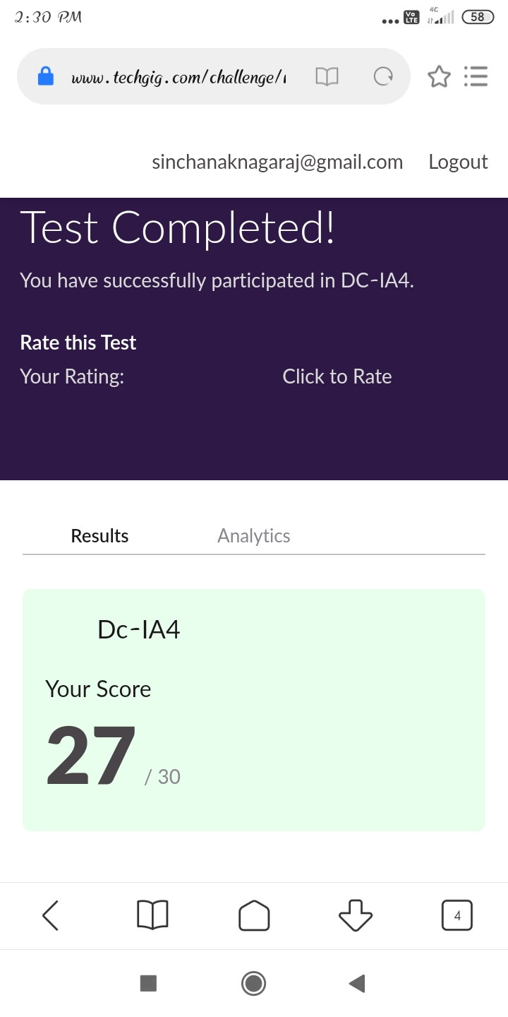

This is the completion of test and marks obtained for 18CS46.

Online Certification Course Summary: In today’s session I have learnt about the Cloud Attributes, Managed Services & Deployment Models,Price Economics, Data Velocity & Distributed Computing

Containers vs VMs, PaaS & Services Taxonomy.

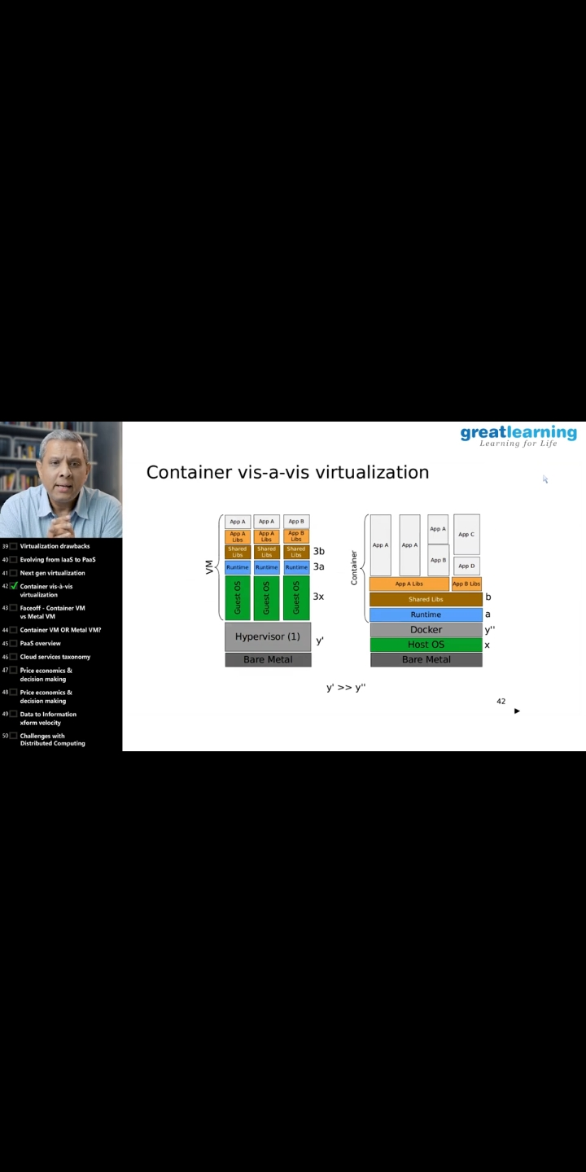



These is the Snap Shot of today’s session.

Online Coding Summary: **Today I had received one program from prof. Vasudev CSE Dept. and prof.Venkatesh CSE Dept. The program is mentioned above in the coding challenges(pg.01). I have also uploaded it to my Github repository.**

